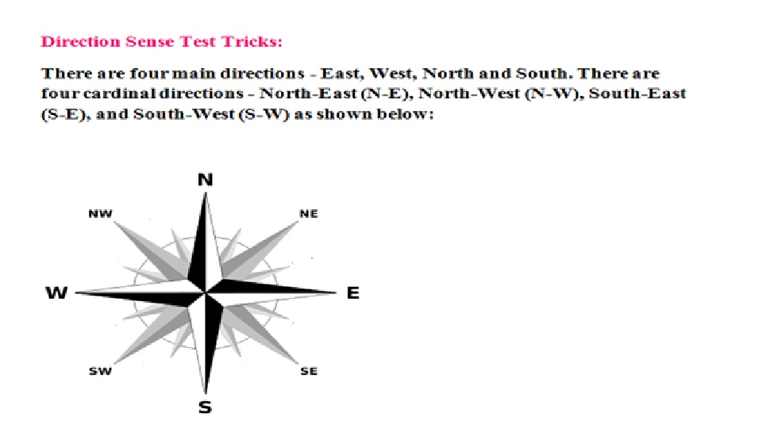

1. A man starts walking towards East. He turns left and then right. In which direction is he now walking?
2. A man starts walking towards South. He turns right, left, left and finally towards right. In which direction is he now ?
3. A man starts walking towards North. He turns left, right, right and left. In which direction is he walking now?
4. A girl starts walking towards South. She turns left, right and left. In which direction is he moving now?
5. A man walks 10m towards East, turns towards North and walks 5m, then turns towards East and walks 20m and finally he walks towards South and walks 5m. How far and in which direction is he from the starting place?
6. Sridhar starts walking towards East. After covering 20m he turns left and covers 15m. Again he turns left and covers 10m and finally he turns left and covers 15m. How far and in which direction is he from the starting point?
7. Suraj starts walking towards East. After walking 10m, he turns left and covers 5m, then he turns right and walks 10m. Then he turns right and covers 20m and finally he turns right and walks 20m. How far and in which direction is he from the starting point?
8. A walks 10m and then takes right and walks 10m. Then every time turning to his left, he walks 5, 15 and 15m respectively. How far is he now from his starting point.
9. A walks 30m East. Then turns left and walks 80m and then he turns right and walks 30m. How far and in which direction is he from the starting position?
10. **A & B start travelling towards North. After walking 10 km. A turns left and B turns right. After travelling 3 km, A turns left and walks 20km and reaches P. After travelling 5 km, B turns towards right and walks 5 km and reaches Q. What is the distance between P and Q?**
11. Bhuvan starts walking towards North. After walking 20m, he turns left and walks 15m. Then he turns left and walks 20m. Finally he turns right and walks 15m. How far and in which direction is he from the starting point?
12. Rohan starts walking towards West. After walking 50m he turns every time left and covers 25m, 50m and 75m. In which direction and how far is he from the starting point?
13. Prabhakar starts walking in front and covers 100m. Then he turns left and covers 50m and then he turns right and covers 30m and finally he turns right and covers 50m. How far is he from the starting place? If his final position is South to the initial position, in which direction did he move in the beginning?
14. Raghu starts walking towards North and walks 80m and then he turns right and walks 120m and finally he turns left and walks 30m. How far and in which direction is he from the starting point?
15. Siddarth starts walking towards North and walks 120m and then turns right and walks 30m. Then he turns right and walks 40m and then turns right and walks 60m and then he turns left and walks 80m and finally he turns left and walks 30m. How far and in which direction is he from the starting point?